**TECHNOLOGICAL INSTITUTE OF THE PHILIPPINES**

**QUEZON CITY**

**COLLEGE OF INFORMATION TECHNOLOGY EDUCATION (CITE)**

**ITE001- Computer Programming 1**

**NAME: Aristotle Buenaventura**

**PROGRAM/SECTION: IS11S1**

**ASSESSMENT TASK: Function Call by Reference**

*The following question support the attainment of Course Intended Learning Outcomes (CILO):* Design computing based solution using control structures, functions, array and other statements.

**INSTRUCTION:** Read and study the assignment below. Solve the problem using C++ programming language, compile, run and screen shot the correct output. Copy and paste the source code or program code and the required sample output (screen shot) in the format below. The output should also display the school name, course name, student name, program, section, date and title of assessment task.

**PROBLEM:** Write a program using **function call by reference** that will arrange the given numbers in ascending. order. Note: use one additional (temp) variable only.

INPUT: int x1=13, x2=14, x3=15, x4=16 , x5=10 , x6=17, x7=18 , x8=11, x9=19, x10=12;

**Sample output:**

The given numbers

13 14 15 16 10 17 18 11 19 12

After swapping, the ascending orders are

10 11 12 13 14 15 16 17 18 19

**SAMPLE OUTPUT:**

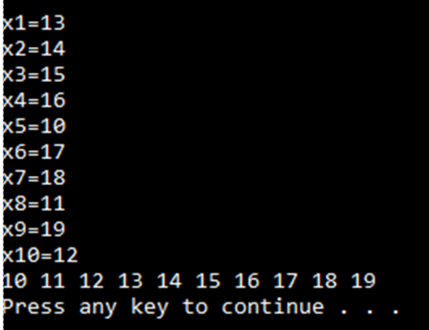

**ANSWER :**

* + 1. **SOURCE CODE:** Write or paste the program code below

#include<iostream>

using namespace std;

void swap (int &x1,int &x2,int &x3,int &x4,int &x5,int &x6,int &x7,int &x8,int &x9,int &x10); // function declaration

int main() { // main function

cout << "\tTECHNOLOGICAL INSTITUTE OF THE PHILIPPINES QUEZON CITY" << endl;

cout << "\t\tFirst Semester S.Y. 2020-2021"<< endl;

cout << "\t\tITE001 Computer Programming 1\n"<< endl;

cout << "Name: " << "Aristotle" << "\t\tDate: " << "1/4/2021" << endl;

cout << "Program: " << "BSIT" << "\t\tSection: " << "IS11S1" << endl;

cout << "Assignment 4.1 Returning Values from Function\n"<< endl;

int x1=13, x2=14, x3=15, x4=16, x5=10, x6=17, x7=18, x8=11, x9=19, x10=12; // int variables

cout << "x1 = " << x1 << endl;

cout << "x2 = " << x2 << endl;

cout << "x3 = " << x3 << endl;

cout << "x4 = " << x4 << endl;

cout << "x5 = " << x5 << endl;

cout << "x6 = " << x6 << endl;

cout << "x7 = " << x7 << endl;

cout << "x8 = " << x8 << endl;

cout << "x9 = " << x9 << endl;

cout << "x10 = " << x10 << endl;

swap ( x1, x2, x3,x4,x5,x6, x7, x8, x9,x10); // function call

cout << "\n" << x1 << " " << x2 << " " << x3 << " " << x4 << " " << x5 << " " << x6 << " " << x7 << " " << x8 << " " << x9 << " " << x10;

}

void swap (int &x1,int &x2,int &x3,int &x4,int &x5,int &x6,int &x7,int &x8,int &x9,int &x10) { // void function

int temp1 = x1,temp2 = x2,temp3 = x3,temp4 = x4,temp5 = x6,temp6 = x7,temp7 = x9; // swapping of numbers

x1 = x5;

x5 = temp1;

x2 = x8;

x8 = temp2;

x3 = x10;

x10 = temp3;

x4 = temp1;

x5 = temp2;

x6 = x10;

x7 = temp4;

x8 = temp5;

x9 = temp6;

x10 = temp7;

// end

}

**OUTPUT:** Paste screenshot of output here.  
  
